The Columbian Exchange

“The accidental or intentional exchange of goods between the Old World and New World”

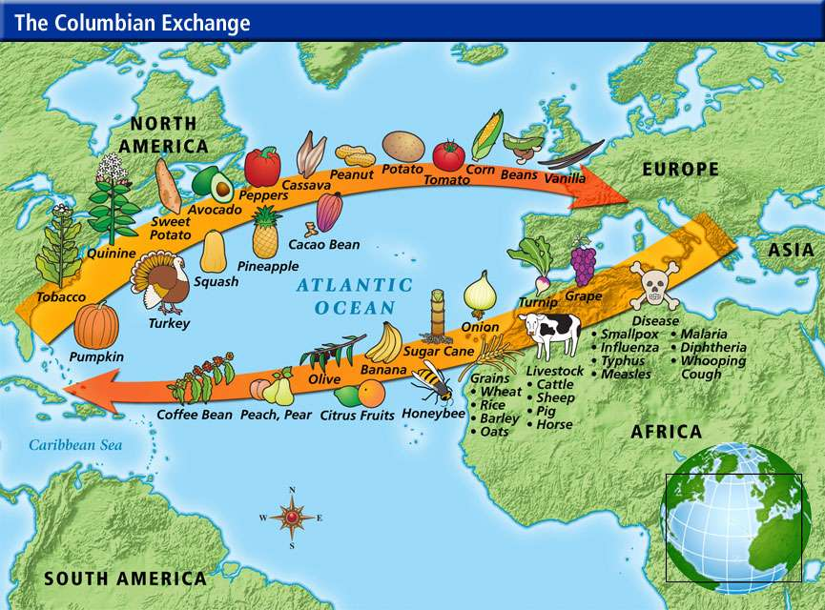

New World to Old World | Old World to New World
- Vanilla  - Rubber  - Tobacco  - Pepper  - Corn  - Tomato  - Pumpkin  - Potato  - Cocoa  - Turkey  - Squash  - Peanut  - Llama  - Pecan  - Raccoon  - Sunflower  - Guinea Pig  -Avocado  -Blueberry  - Pineapple | - Onion  - Olive  - Sugar Cane  - Citrus Fruit  - Honey Bee  - Grapes  - Rat  - Donkey  - Banana  - Coffee  -Watermelon  - Domestic Rabbit  - Cinnamon  - Chicken  - Wheat and Barley  - Zebra Mussel  - Apple  - Horse  - Lettuce  -Deadly Diseases
HEAD’S UP RULES- COLUMBIAN EXCHANGE

Team playing

- Your team will choose one person to be the guesser, one person to be the cardholder, and the rest of the team will be the clue-givers.
- Cardholders will stand behind the guesser and show the clue-givers the card.
- Clue givers will give clues to the guesser as to what the item is.
  - Clues cannot rhyme with the item
  - Clues cannot have the name of the item in it.
  - If you cannot guess one, either the clue-giver or the guess can say next and the card will be put back in the pile (it can be guessed later if time remains).
  - I will yell “point!” if the answer is guessed correctly
- Team will have 80 seconds to guess all 10 items.
- The team who guesses the most items wins

Team not playing

- Your team will quietly watch the game!
- You may not give hints to other teams, verbally or non-verbally.
- Follow along with the items stated. Be sure to note any important ones in your chart!

